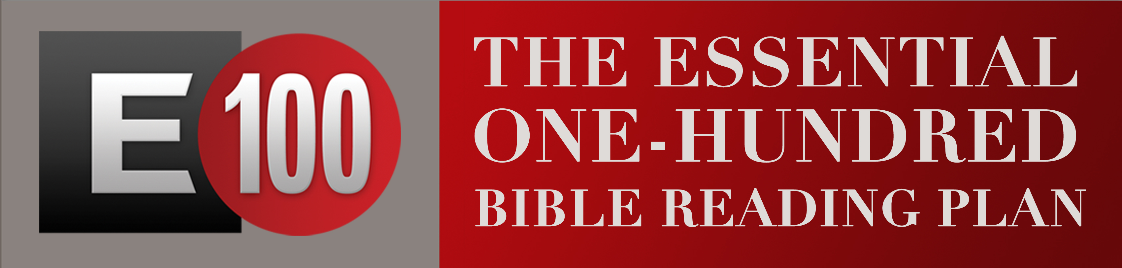
​

Congratulations for joining us in the E100 Bible Reading Challenge! Whether you are participating in a self-study, a family study, a current small group study or a new triad here are some details for you to know as we look forward to starting this together shortly on September 14!

What materials are needed to begin?

Your Bible

The book that is available in the FLC foyer for a $5 donation ($10 for family book) -OR-

You may use the questions on the church website, Facebook, or on the same E100 table in the foyer. These materials are for all group types – just decide what you works for you or your group.

What else?

Every person participating will find it helpful to use the brochure that will be
will also be available on the website AND hard copies will be on the E100 table in the FLC foyer.

Suggestions:
Contact the other members of your group and find a weekly day and time that you will meet together. Same if you are meeting as a family – having a time and day each week that you come together is helpful for each person.
If you are meeting in a group/ triad – we suggest that you talk about the stories that are listed in the weekly groupings. Some group members might read ahead a few stories based on their reading planner, however, it makes it easier – even if reading ahead – if the group sticks to the weekly groupings for discussion so there isn’t confusion. This approach will also go with the sermons.

