Who I Am In Christ

Each day ask God if there is something I need to change in my thought life or in my actions in order to really “live” this truth.

Affirmation 5 – I am united with the Lord and I am one spirit with Him.

“But whoever is united with the Lord is one with him in spirit.”
1 Corinthians 6:17

Other Scriptures: Romans 14:8, I Peter 1:18-19, Hebrews 9:11-12

Affirmation 6 – I have been bought with a price, I belong to God.

Do you not know that your bodies are temples of the Holy Spirit, who is in you, whom you have received from God? You are not your own; you were bought at a price. Therefore honor God with your bodies.
1 Corinthians 6:19-20

Other Scriptures: Ephesians 1:22-23, Colossians 1:24, Romans 12:5

Affirmation 7 – I am a member of Christ's Body.

Now you are the body of Christ, and each one of you is a part of it.
1 Corinthians 12:27

Other Scriptures: 2 Corinthians 1:1, Revelation 5:8, Ephesians 6:18

Affirmation 8 – I am a saint, a holy one.

From Paul, an apostle of Christ Jesus by the will of God, to the saints [in Ephesus], the faithful in Christ Jesus. Ephesians 1:1

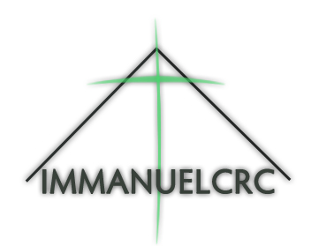
Other Scriptures: Romans 8:14-30, Romans 9:6-8, I John 3:1-2

It is for freedom that Christ has set us free.
Stand firm, then, and do not let yourselves be burdened again by a yoke of slavery.
Galatians 5:1

Prayer for Salvation or Recommitment

Dear Heavenly Father,

Thank you for sending Jesus to die on the cross for my sins. I acknowledge that I have sinned and that I cannot save myself. I come to you asking for the forgiveness of my sins. I confess with my mouth and believe with my heart that Jesus is Your Son. I believe that Jesus rose from the dead. I ask You right now to come into my life and be my Lord and Savior. I pray that You will lead me into a knowledge of the truth so that I can experience my freedom in Christ and be transformed by the renewing of my mind. In Jesus’ Name, Amen.

Nothing can separate you from the love of God that is Christ Jesus. Romans 8:39
Freedom in Christ – Step One

REAL OVERCOMES COUNTERFEIT

Judges 17-18

What does the Lord require in the first commandment?

That I, not wanting to endanger my salvation, avoid and shun all idolatry, magic, superstitious rites, and prayer to saints or to other creatures. That I sincerely acknowledge the only true God, trust him alone, look to him for every good thing humbly, and patiently,
love him, fear him, and honor him with all my heart.
In short,
that I give up anything rather than go against his will in any way.
(Heidelberg Catechism Q/A 94)

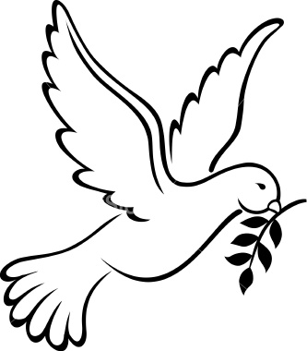

Dear Heavenly Father,
I ask you to bring to my mind anything and everything that I have done knowingly or unknowingly that involves occult, cult or non-Christian teaching and practices. I want to experience Your freedom by rejecting all counterfeit teachings and practices and all false guidance. In Jesus’ name, I pray, Amen.
Non-Christian Spiritual Inventory
  - Ancestor Worship
  - Astrology
  - Bloody Mary
  - Crystal Ball
  - Horror based music, books, video games.
  - Horror films
  - Other Religions – Buddhism, Hinduism, Islam etc.
  - Ouija Board
  - Satanism
  - Sensing an evil presence in your room at night or in your dreams
  - Spirit Guides
  - Voices in your head
  - Witchcraft/Wicca
Other: ____________________________________________________________
Other: ____________________________________________________________

Lord Jesus,
I freely confess that I have knowingly or unknowingly participated in or experienced ____________________ and I reject them as counterfeits. I resolve with reliance on the Holy Spirit to turn away from them. Thank you for Your forgiveness and cleansing. In Jesus’ name I pray. Amen.

Kingdom of Light

My name is now written in the Lamb’s Book of Life.
I am part of the Bride of Christ.
I am under the new covenant of grace in Christ Jesus.
God is my heavenly Father.
I belong to Jesus.
I accept the leading of the Holy Spirit.

