Who I Am In Christ

Each day ask God if there is something I need to change in my thought life or in my actions in order to really “live” this truth.

Affirmation 13 – I am free forever from condemnation.
Therefore, there is now no condemnation for those who are in Christ Jesus, because through Christ Jesus the law of the Spirit who gives life has set you free from the law of sin and death. - Romans 8:1-2

Other Scriptures: Romans 8:39, John 3:18, I John 3:18-20, John 5:24

Affirmation 14 – I am assured that all things work together for good.
And we know that in all things God works for the good of those who love him, who have been called according to his purpose. Romans 8:28

Other Scriptures: I Corinthians 1:8-9, I John 1:3-4, Isaiah 49:7

Affirmation 15 – I am free from any condemning charges against me.
If God is for us, who can be against us? He who did not spare his own Son, but gave him up for us all—how will he not also, along with him, graciously give us all things? Who will bring any charge against those whom God has chosen? It is God who justifies. Who then can condemn? No one. Christ Jesus who died—more than that, who was raised to life—is at the right hand of God and is also interceding for us. – Romans 8:31-34

Other Scriptures: Hebrews 7:25, I John 2:3-6, Isaiah 50:8-9

Affirmation 16 – I cannot be separated from the love of God.
Who shall separate us from the love of Christ?...No, in all these things we are more than conquerors through him who loved us… nothingin all creation, will be able to separate us from the love of God that is in Christ Jesus our Lord.

Other Scriptures: I Corinthians 15:57, I Peter 3:21-22,
Ephesians 2:11-13
Freedom in Christ – Step Three

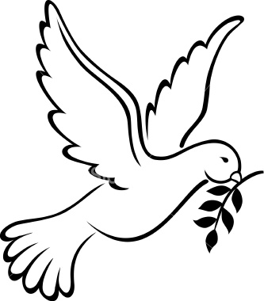
It is for freedom that Christ has set us free.
Stand firm, then, and do not let yourselves be burdened again by a yoke of slavery.
Galatians 5:1

Prayer for Salvation or Recommitment

Dear Heavenly Father,

Thank you for sending Jesus to die on the cross for my sins. I acknowledge that I have sinned and that I cannot save myself. I come to you asking for the forgiveness of my sins. I confess with my mouth and believe with my heart that Jesus is Your Son. I believe that Jesus rose from the dead. I ask You right now to come into my life and be my Lord and Savior. I pray that You will lead me into a knowledge of the truth so that I can experience my freedom in Christ and be transformed by the renewing of my mind.
In Jesus’ Name, Amen.

Nothing can separate you from the love of God that is Christ Jesus. Romans 8:39
STEP 3: FORGIVENESS OVERCOMES BITTERNESS

What does the fifth request mean?
Forgive us our debts, as we also have forgiven our debtors means,
Because of Christ’s blood, do not hold against us, poor sinners that we are, any of the sins we do or the evil that constantly clings to us. Forgive us just as we are fully determined, as evidence of your grace in us, to forgive our neighbors.
(Heidelberg Catechism Q/A 126)

FORGIVENESS
- Forgiveness is not forgetting.
- Forgiveness does not mean that the offense was not sinful.
- Forgiveness does not let the other person off God’s hook.
- Forgiveness is agreeing to live with the consequences of another person’s sin.
- Do not wait for the other person to ask for forgiveness.
- Forgiveness cannot wait until you feel like forgiving.
- Forgiveness is a choice, a decision of your will.

And forgive us our debts, as we also have forgiven our debtors. – Matthew 6:12

“In your anger do not sin”: Do not let the sun go down while you are still angry, and do not give the devil a foothold. – Eph. 4:26-27

Be kind and compassionate to one another, forgiving each other, just as in Christ God forgave you. – Ephesians 4:32

Do not take revenge, my dear friends, but leave room for God’s wrath, for it is written: “It is mine to avenge; I will repay,” says the Lord. – Romans 12:19

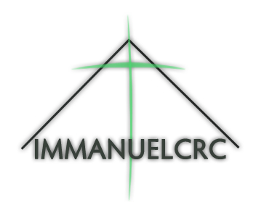
Jesus said, “Father, forgive them, for they do not know what they are doing.” – Luke 23:34

Name Offense Feeling
(People who hurt me) (What They Did) (Made me feel)

1.

2.

3.

4.

5.

6.

7.

PRAYER
Lord, I choose to forgive (name of person) for (what they did to hurt you) even though it made me feel (name the painful feelings) .

Lord, I choose not to hold on to my resentment. I relinquish my right to revenge and ask you to heal my damaged emotions. I thank you for setting me free from the bondage of my bitterness.
In Jesus name I pray, Amen.

