IMMANUEL
Christian Reformed Church

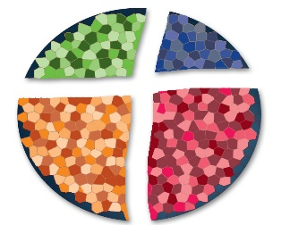

3520 Kiel Street, Hudsonville, Michigan 49426
Phone: (616) 669-9725
Email: office@immanuelcrc.com

PRAYER REQUESTS

We express our sympathy to Jessie De Groot on the death recently of her sister-in-law, Audrey Berkenpas, in FL. May the Lord comfort and uphold the family.

Pat Duimstra (District #5) – receiving in-home physical therapy

Laurie Kooienga (District #8) – stem cell transplant recovery

Joe Lems (District #6)– severe back pain

Keith Meinema Sr (District #5) – chemotherapy & radiation

Sharon Ondersma (District #4) – M.S.

Cathy Ter Avest (District #4) – spinal fusion surgery recovery

Evelyn Vander Kooi (District #2) – hospice care

Pete Van Rijs (District #7) – durable cancer remission

Homebound: Hazel Coy, Kay Alsum, Clarence Pohler

Staff: Kris Porter, Worship Planner

Missionaries: Lee & Carolyn Baas,
WITS Missionary Support Ministry

Young Adults: Katelyn Vander Ploeg, Tara Vandermeer,
Corbin De Boer

Military: Major Ron Thenn – Army (Hawaii)

Membership Update
The membership of Alan & Lisa Finnie and family was transferred to Covenant Community Church in Hudsonville.

Immanuel Membership Info
Are you interested in becoming a member of Immanuel? Is now the time for you to make profession of faith? Do you desire to take the next step in becoming a more faithful disciple of Jesus? Please find the sign-up sheet on Pastor Jake's door.

Hand2Hand
For the month of March, we are collecting stew & white rice. You may place your donations in the cart in the FLC foyer.

March Offerings
General Fund
Short-Term Missions
Benevolent Fund
GEMS Girls Clubs
Cincinnati Mission Trip
Legacy Fund – Chr Education

